Duong Le

IT360

Practice Exam

2) Item was created with a name is UMB-Mug and Purchased by a vendor name Mug-DUONGLE with a unit price was $5.00.

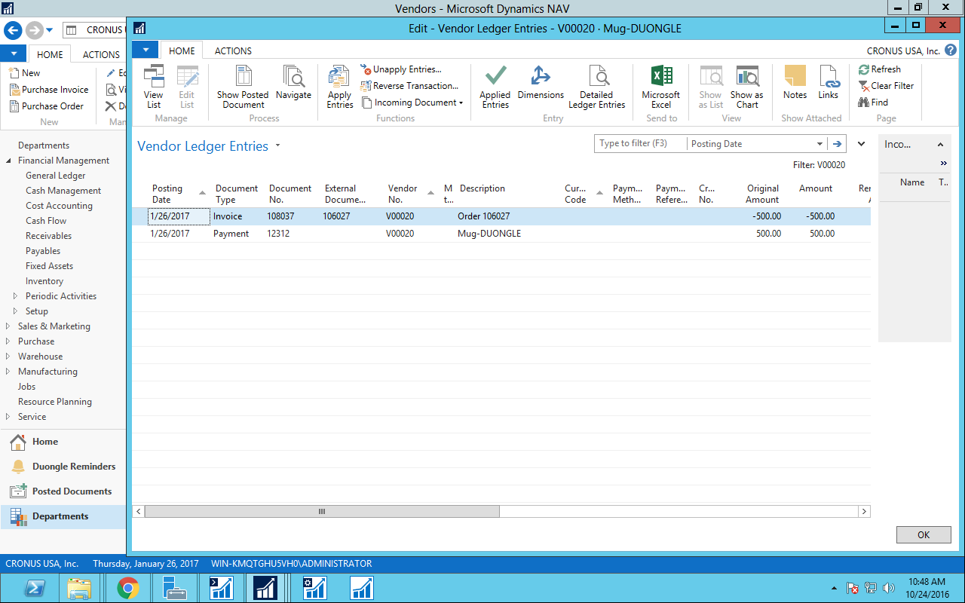

Vendor purchased 100 units with $5.00/unit and paid all of them.

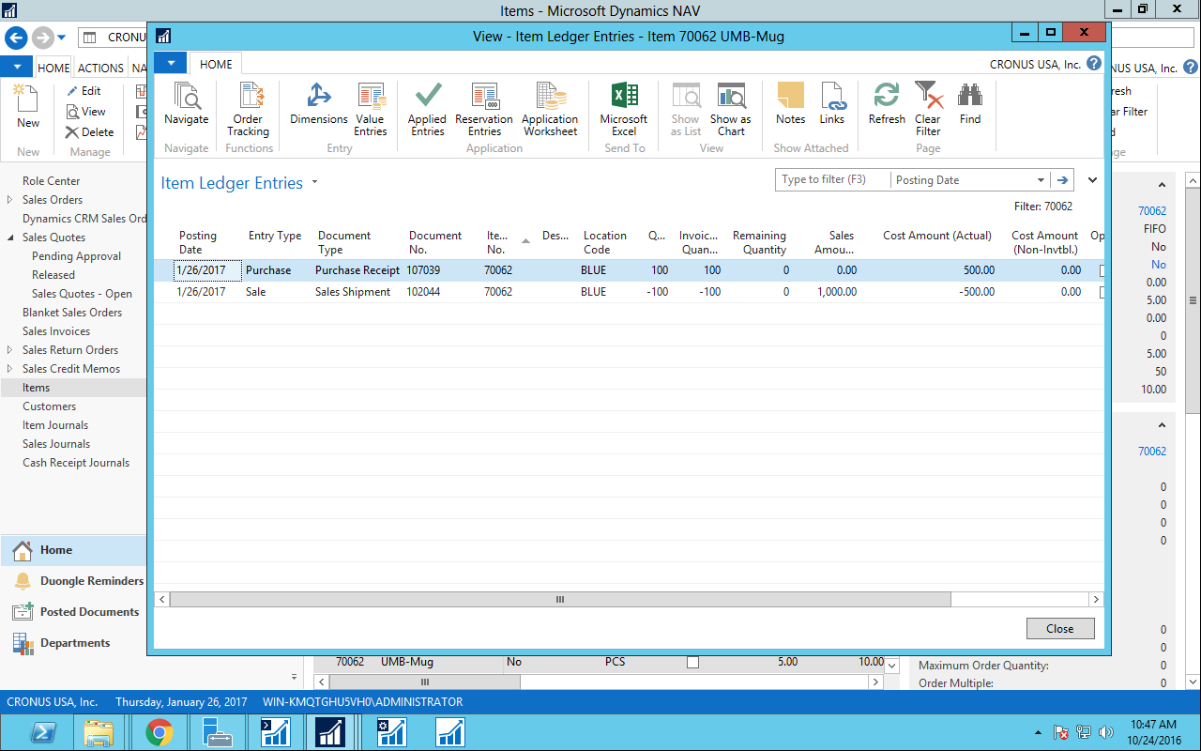

Now, Vendor Mug-DUONGLE sale these items to a customer CUS-DUONGLE with $10.00/unit.

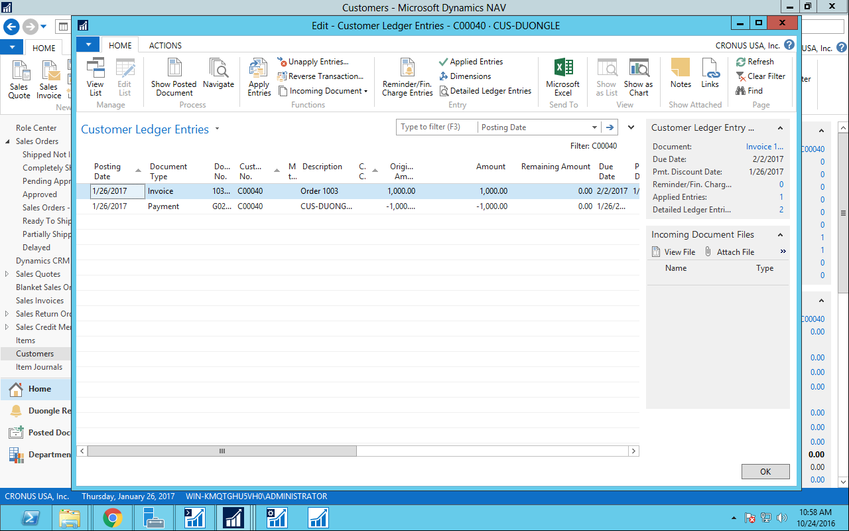

Customers received the items and paid to vendor with the price that Vendor had been assigned before, which is $10.00/unit and $1000.00 over 100 units.

1. **Integrated Purchase and Sales process**

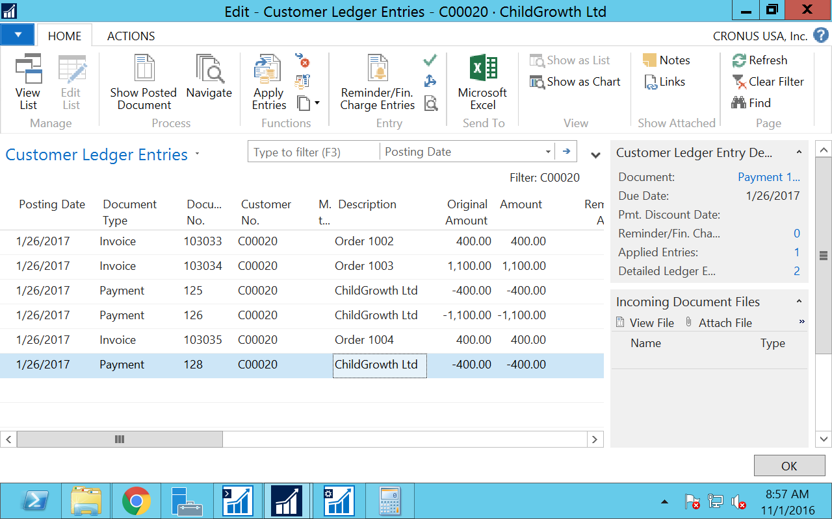

This is an order of customer ChildGrowth, I tried different one. But the one with Document number 125 is the payment from Childgrowth since that request a quote, and I gave them 20 cents on each item. That is why they paid only $400.00 instead of $440.00.

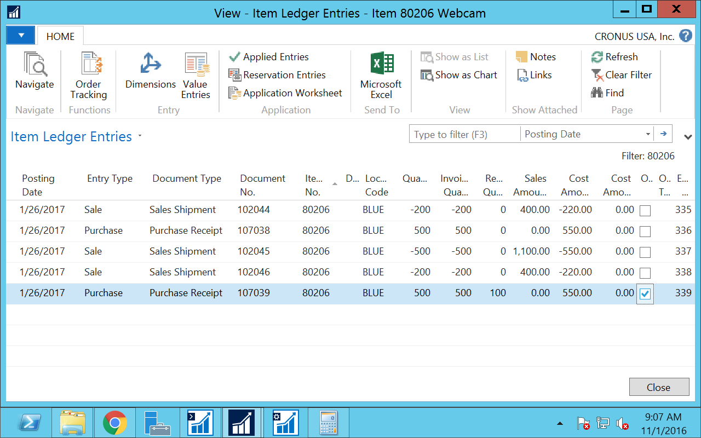

Item ledger shows that 200 items was purchased by ChildGrowth with sale amount $400.00, discount included. Also, a purchase from vendor Service Electronics Ltd with 500 units with $550.00 is showing here because I took this snapshot after I did all together.

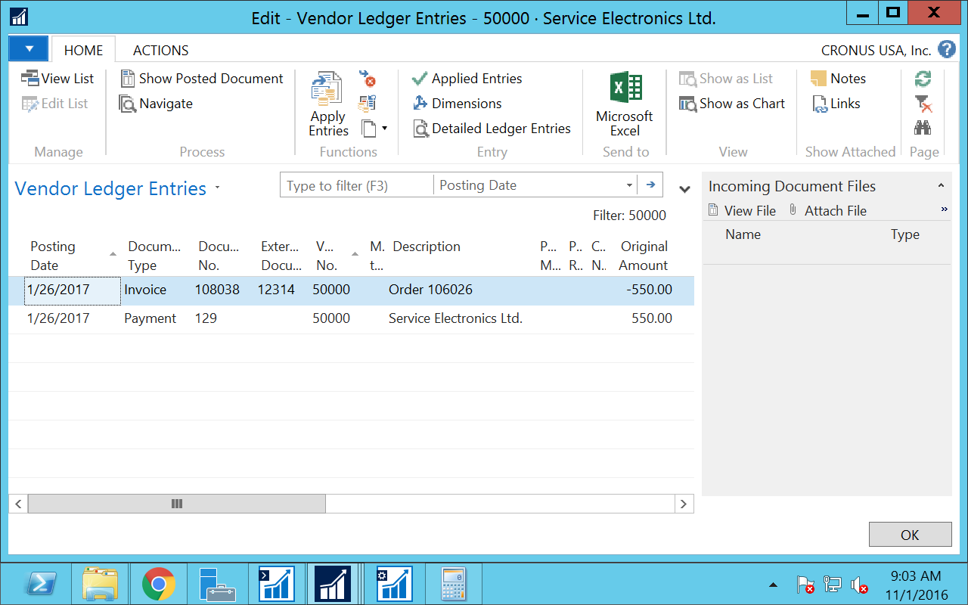

This is showing that the purchase from ChildGrowth and payment to vendor